PROJECT 3 - REST API - Oscar Awards

POSTMAN SCREENSHOTS

GET Request to get all the oscar award list

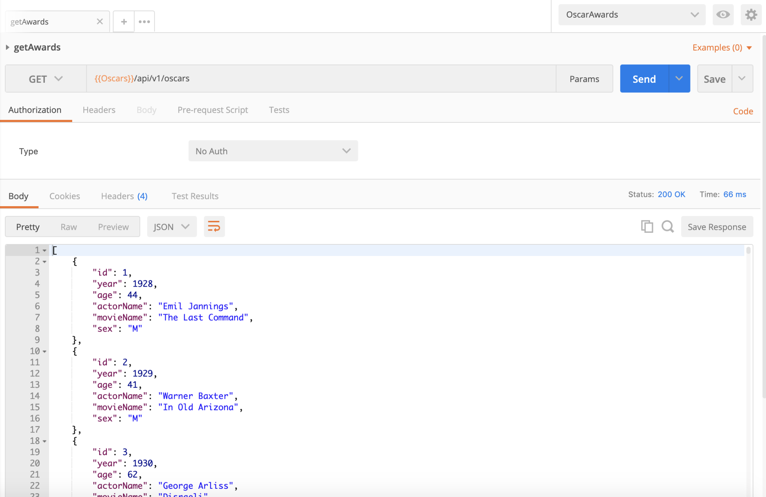

GET Request to get one record from the list

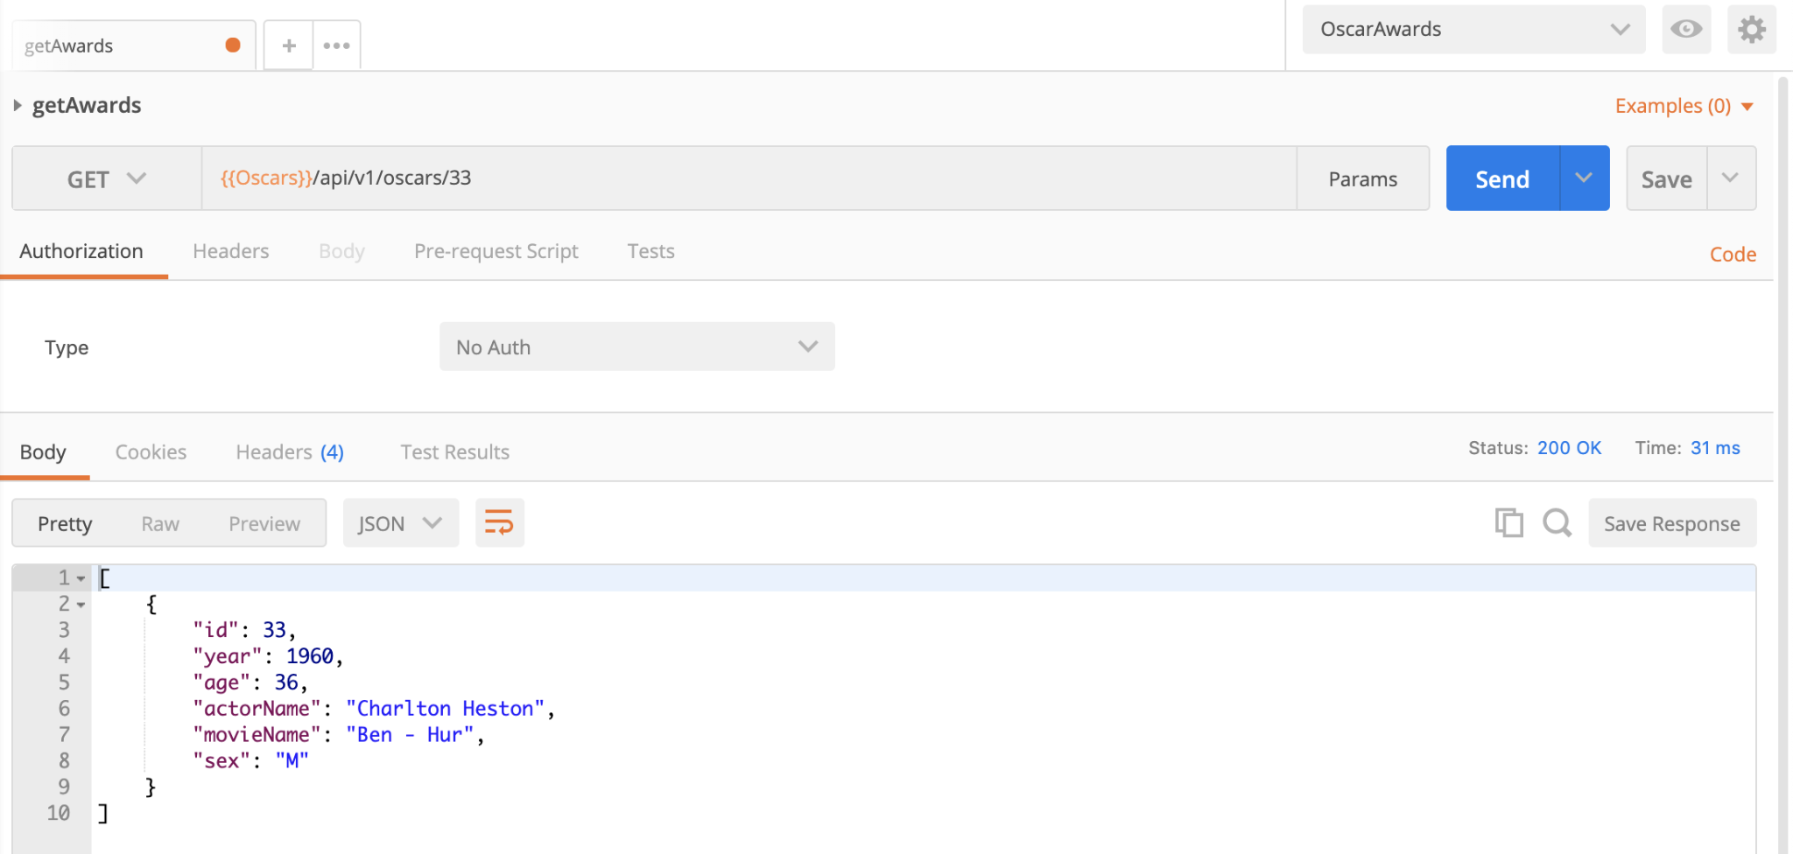

Adding a new award to the existing list using POST

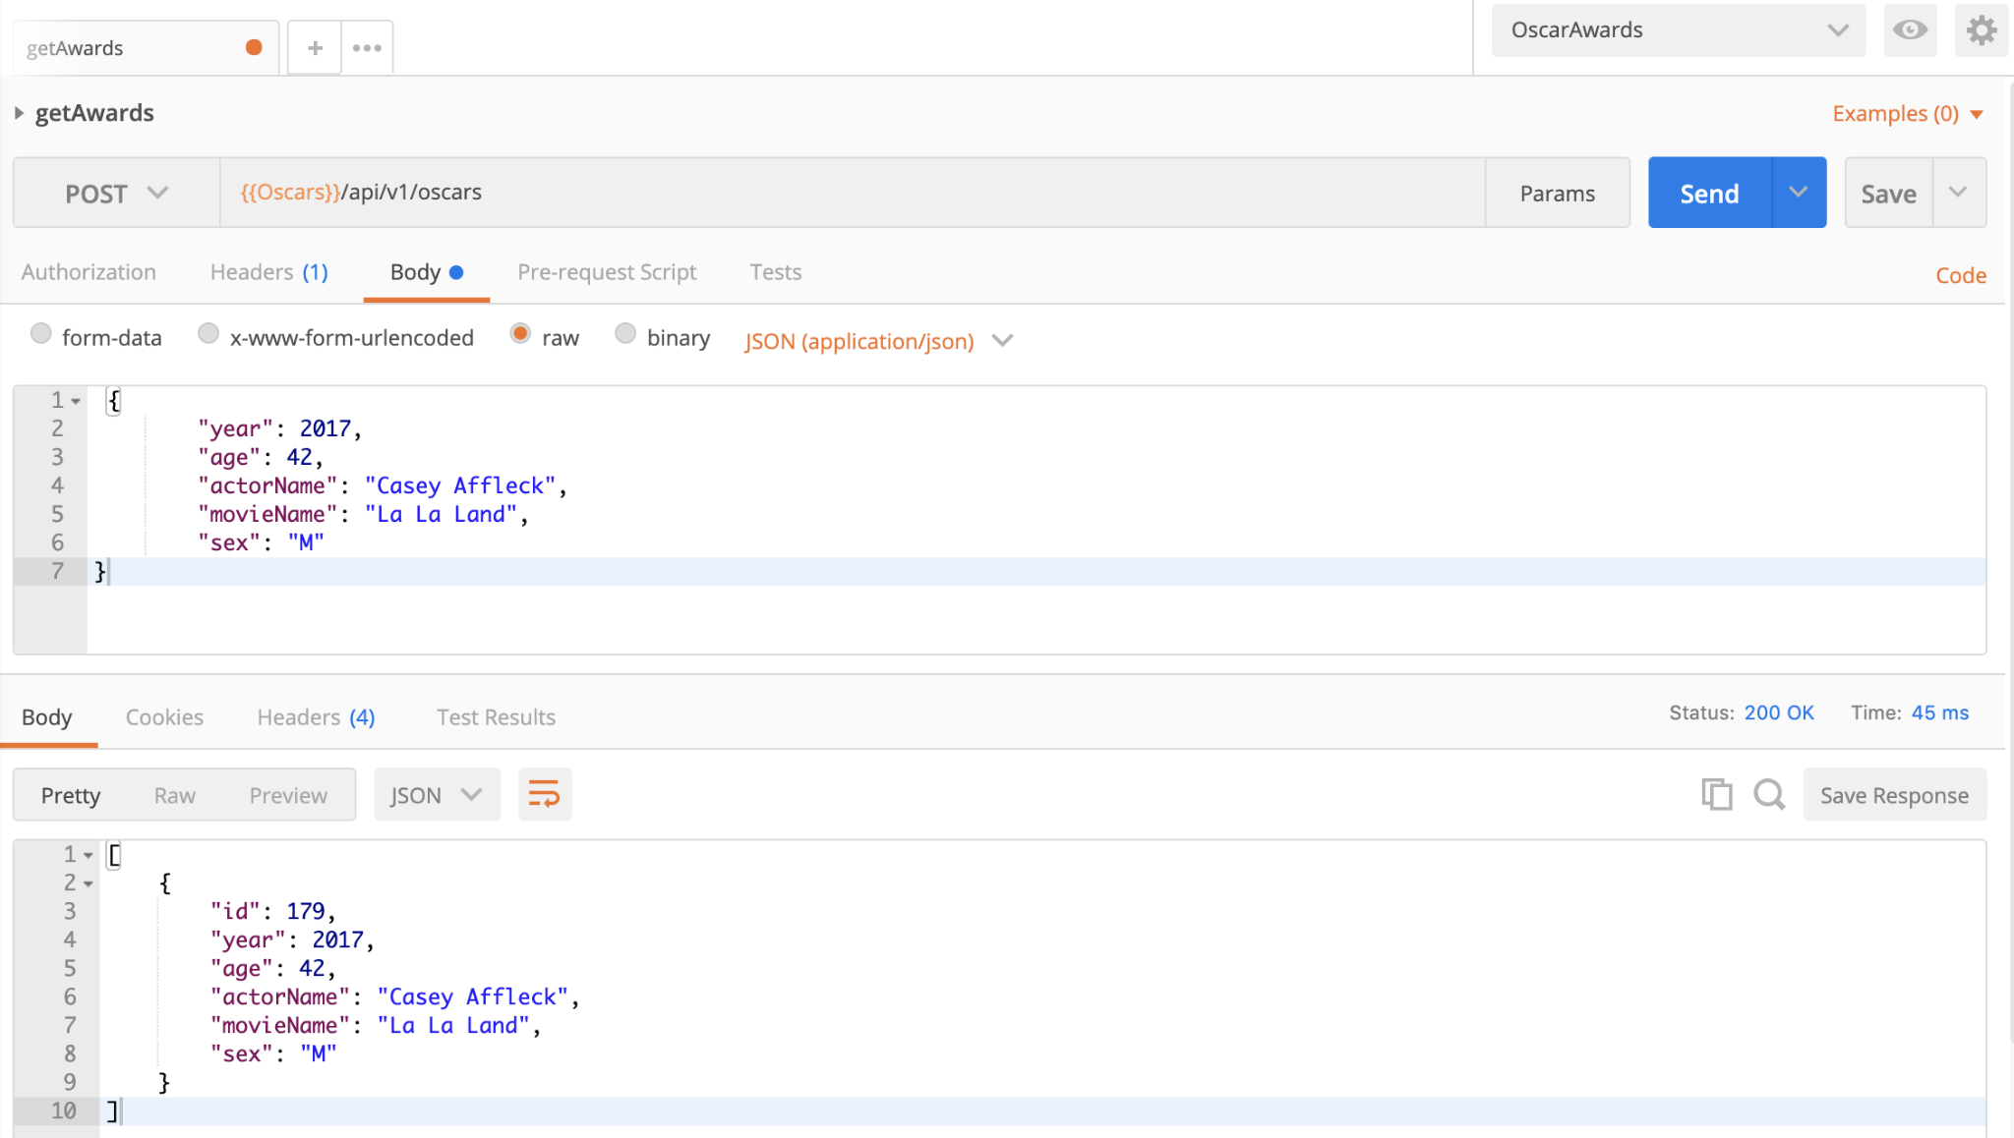

Editing a record by using PUT request

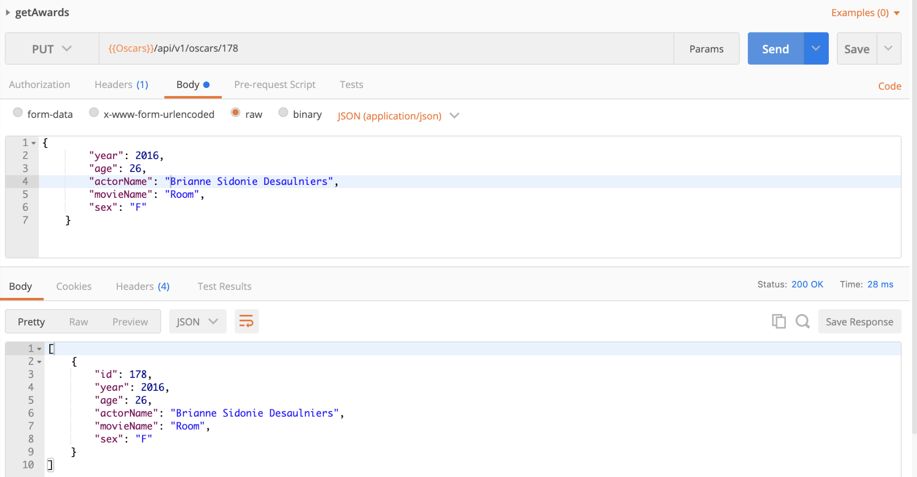

Deleting a record using DELETE request

